Project Roadmap: Belle Vie Digital Experience
Client: Shawna Fearneley, Belle Vie Hair Spa Total Investment: $1,500 Timeline: 4-5 Weeks (Est.)
Note: This timeline relies on timely feedback during the approval phases. Delays in feedback may adjust the final launch date.

1. Payment Schedule (Phased)
This is structured into three milestones. This ensures you see clear deliverables at every step and allows us to organize the business logic before we start designing.
Phase 1: Discovery, Audit & Content Strategy ($500)
- Due: Upon Start of Project.
- The Work: I will conduct a full digital audit of your current online presence (Facebook, Gloss Genius, Website). I will curate the best of your existing photos and identify gaps where new imagery is needed to match the luxury vibe.
- Deliverable: A finalized Project Proposal and a Content Audit that organizes your information into a clear plan for the new site.
Phase 2: Design Approval ($500)
- Target: Week 3 (Subject to Phase 1 Approval)
- The Work: Creating the visual look of the site ("The Vibe").
- Deliverable: You will review and approve the Visual Mockup and Sitemap before we begin the final build. This ensures you love the design before it is coded.
Phase 3: Launch & Handover ($500)
- Target: Week 5 (Subject to Design Approval)
- The Work: Final development, mobile optimization (ensuring it looks great on phones), and platform transfer.
- Deliverable: The live website launch, transfer of ownership, and a final walkthrough.

2. My Immediate Next Steps (Content Gathering)
To save you time, I am currently going through your existing platforms (Facebook, Gloss Genius, and your current website) to pull photos, testimonials, and service descriptions.
I will organize these into the new 5-Page Sitemap outlined below. This allows me to see exactly what we have and where we might need new content.

3. Visual Identity (Branding Guide)
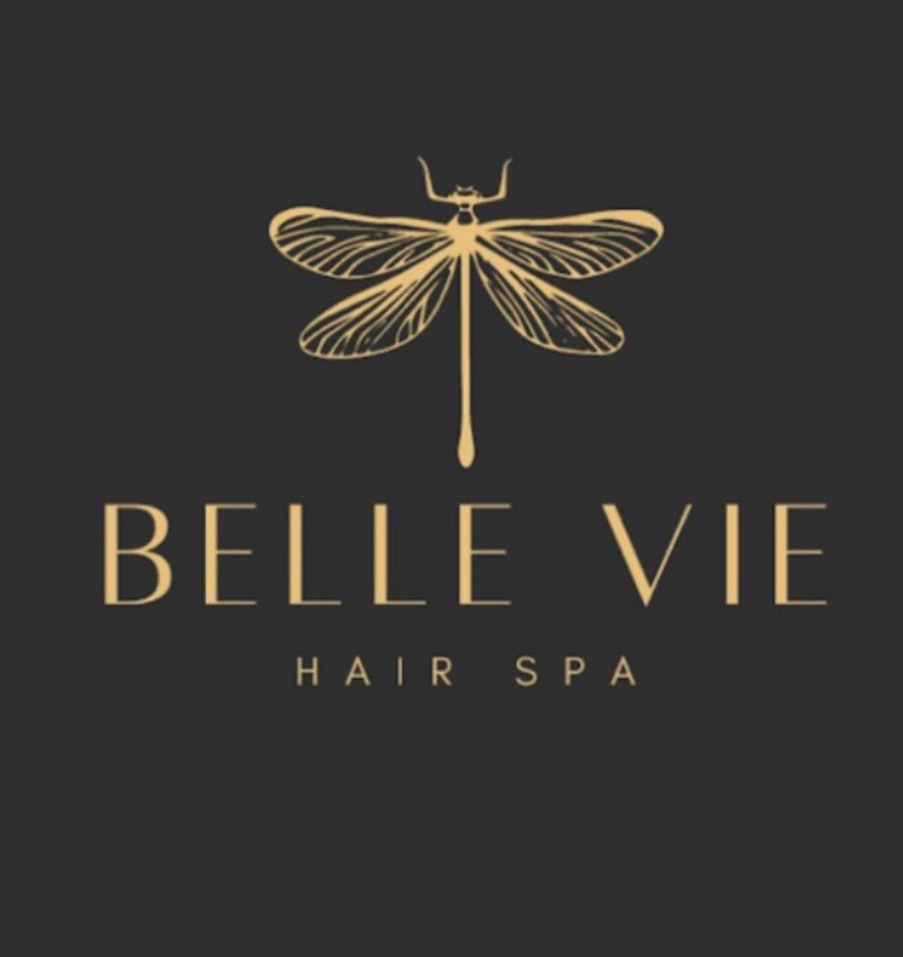
To achieve the "Organic Luxury" vibe, we will implement a consistent style guide based on your current aesthetic.
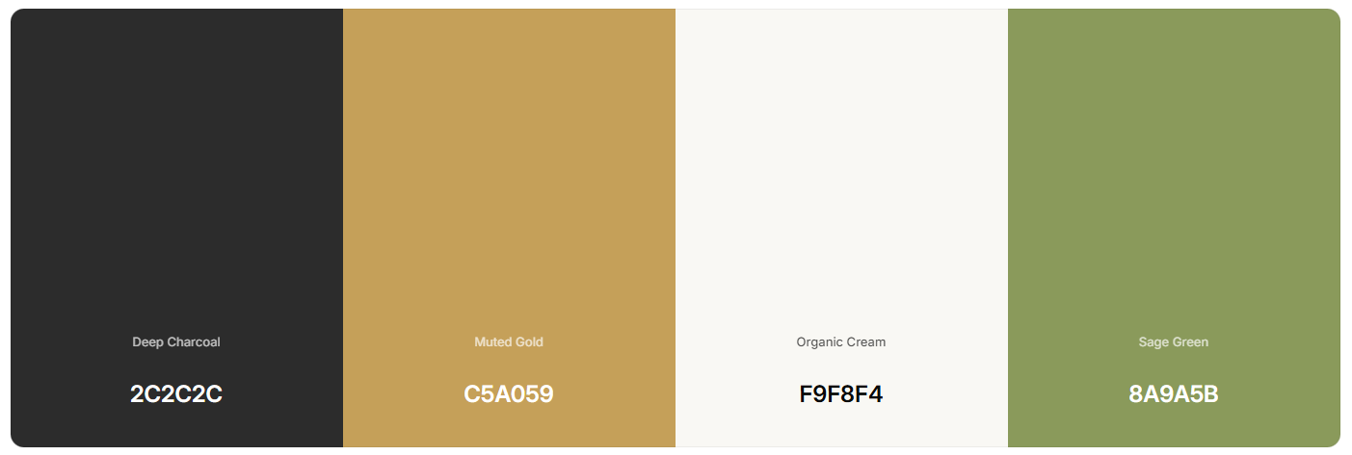
Color Palette:

- Deep Charcoal (Primary Text): #2C2C2C — Softer and more luxurious than pure black.
- Muted Gold (Accents): #C5A059 — For high-end highlights and buttons.
- Organic Cream (Backgrounds): #F9F8F4 — A warm, natural alternative to clinical white.
- Sage Green (Wellness): #8A9A5B — To distinguish the Wellness Suites from the Salon.
Typography Strategy:
- Brand Accent Font: Tenor Sans (The Logo Match. Use for Navigation, Buttons, and Section Labels.)
  - Sample: HAIR SPA | WELLNESS | MEMBERSHIPS | CONTACT
- Primary Headline Font: Playfair Display (The "Editorial" Voice. Use for Big Titles and Taglines.)
  - Sample: "Where beauty is rooted in nature—and nurtured by faith."
- Body Copy Font: Montserrat (The "Functional" Text. Use for Paragraphs and Pricing.)
  - Sample: "Drift into pure relaxation with our signature head spa."

4. The Sitemap (Content Strategy)
Page 1: Home (The Showcase & Brand Experience)
- Goal: A visually immersive "scroll" that establishes the brand voice ("Faith, Nature, Luxury") and validates the user's choice to visit. It acts as a highlight reel.
- Key Sections (The "Showcase"):
  - Hero Section: High-impact video/imagery that immediately communicates "Sanctuary".
  - The Introduction: A snapshot of the "Why" – The fusion of organic hair care and holistic wellness.
  - Visual Service Teasers: High-level blocks for "The Head Spa," "The Salon," and "Wellness Suites"
  - Social Proof: Testimonials/Reviews slider.
  - The "Vibe" Check: Imagery that supports the "Rooted in Nature, Nurtured by Faith" motto.
Page 2: The Hair Spa (Salon Service Structure)
- Goal: To organize the extensive salon menu into digestible categories.
- Structural Blocks (To be populated after Deep Dive):
  - The Head Spa Experience: Dedicated section for the signature service (Scalp analysis, etc.).
  - Menu Categories: Placeholders for Cuts, Color (Arete Organic Line), and Treatments.
  - Men’s Grooming: A designated space to ensure male clients feel welcome (Cuts & Men's Head Spa).
  - Booking Policy: A placeholder area to clearly state deposits and cancellation rules once confirmed.
Page 3: Wellness Suites (The Membership Hub)
- Goal: To shift the user from "booking a service" to "joining a lifestyle." This page is structurally designed to sell memberships.
- Structural Blocks:
  - Education: "What is Infrared?" / "Benefits of Cold Plunge" (SEO content).
  - Membership Tiers: A pricing table layout
  - Single Sessions: Drop-in options
  - Wellness Booking: Distinct call-to-action for the wellness side.
Page 4: Our Philosophy (Connection & Trust)
- Goal: To humanize the brand and house the visual assets.
- Structural Blocks:
  - The Founder's Story: Shawna’s note on grace and renewal ("Come as you are").
  - The Team: Staff bios (if applicable).
  - The Space: A dedicated "Gallery" section to handle the high-resolution imagery without slowing down the Home page.
Page 5: Contact & Logistics
- Goal: Operational clarity.
- Structural Blocks:
  - Location: Map and directions
  - The "Hours" Block: A layout designed to handle complex/split hours (Salon vs. Wellness) to resolve current confusion.
  - Inquiry Form: For general questions.

